Secret
- A Secret YAML file in Kubernetes is a configuration file used to define a Secret object that securely stores sensitive information such as passwords, API keys, tokens, certificates, and credentials in Base64-encoded format, and allows this data to be safely accessed by Pods through environment variables or mounted files (volumes).
- A Secret is used in Kubernetes to store sensitive data like:
  - Passwords
  - Tokens
  - API keys
  - Database credentials
- Unlike ConfigMap, Secrets are meant for confidential data.
Step 1: create namespace and clone git-repo
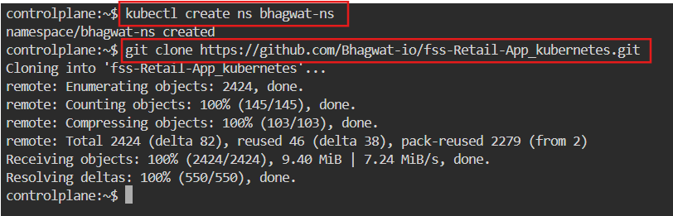

Step 2: Convert credentials in Base64-encoded format
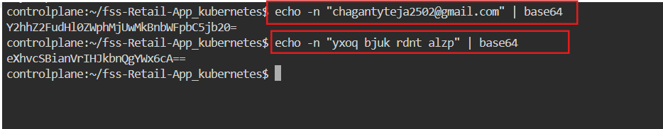

Step 3: Create Secret.yaml file use the base64-encoded format as value
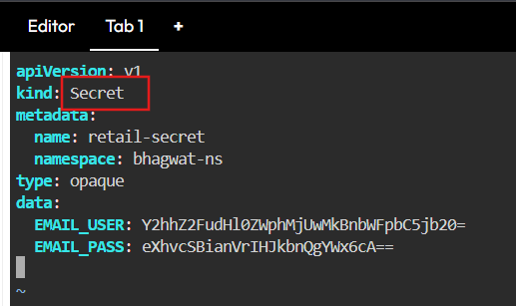

Step 4: Make change in userprofile-deployment.yaml use value from
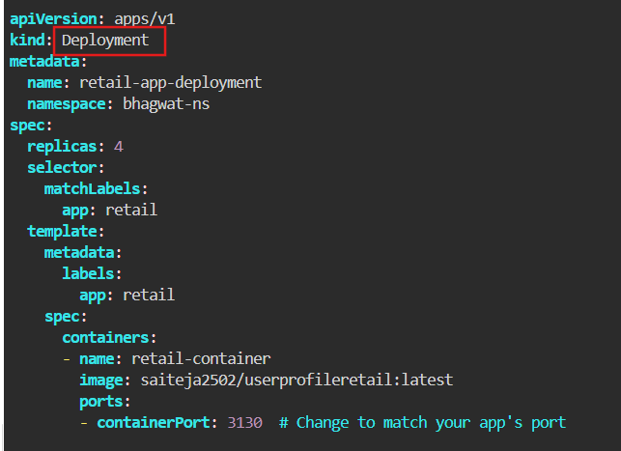
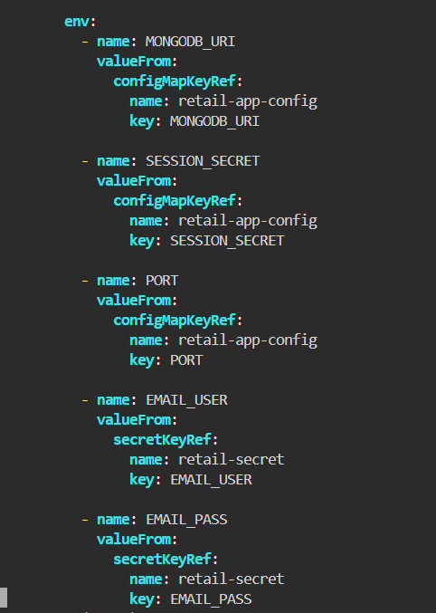
Step 5: Deploying resources

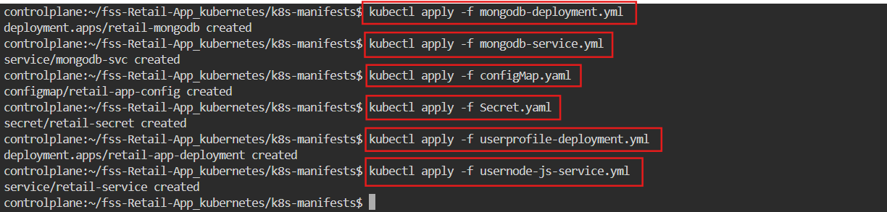

Step 6: Checking Status
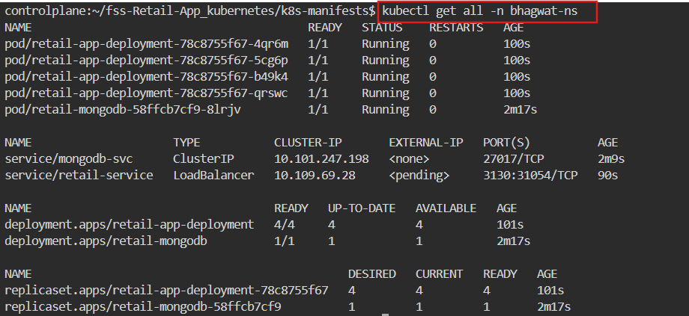

Step 7: Getting Nodes

Step 8: Checking is it running using (Internal IP) terminal

